NAME: Kaveri Avinash Jarhad

Assignment No: 6

Q1. Variable and String Manipulation
Write a shell script that:
- Accepts your first name and last name as input.
- Stores them in variables.
- Displays:
  - Full Name
  - Length of the full name
  - First character of the first name
  - Last character of the last name
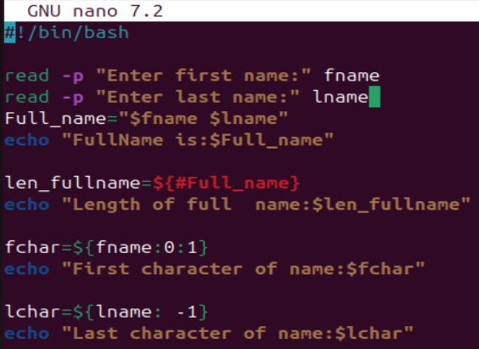
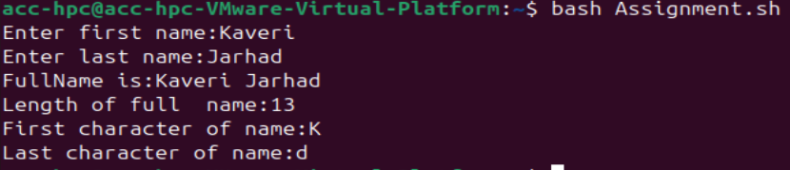

Q2. For Loop with Numbers
Write a shell script that:
- Uses a for loop to print numbers from 1 to 20.
- Print "Even" beside even numbers and "Odd" beside odd numbers.

Sample Output
1 - Odd
2 - Even
3 - Odd
...
20 - Even
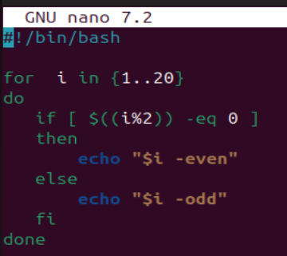
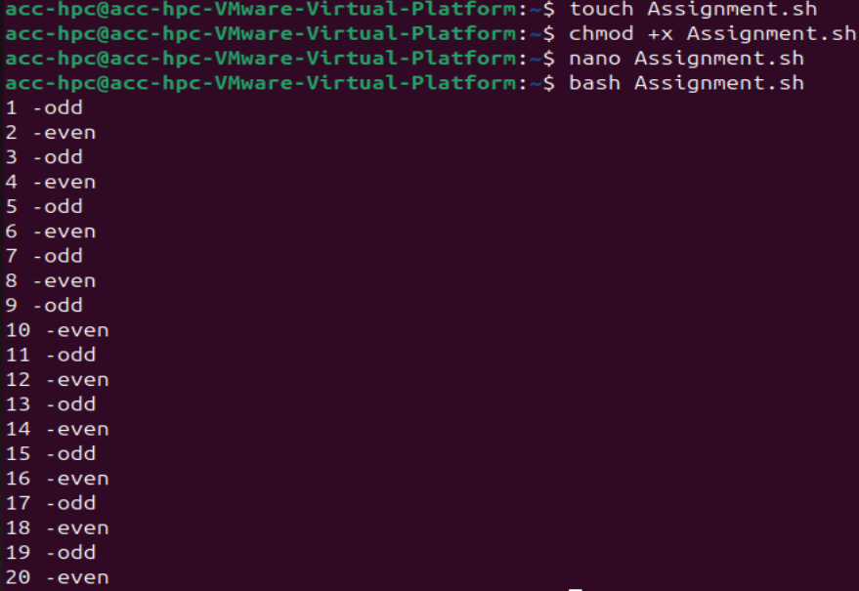

Q3. Directory Operations
Write a shell script that:
- Accepts a directory name from the user.
- Checks whether it exists. ( use option -e to check)
- If it exists, display:
  - Total number of files
  - Total number of directories
- Otherwise, display an appropriate message.

Q4. File Information
Write a shell script that:
- Accepts a filename as input.
- Checks whether the file exists.
- If it exists, display:
  - File size
  - Number of lines
  - Number of words
  - Whether the file is readable and writable.
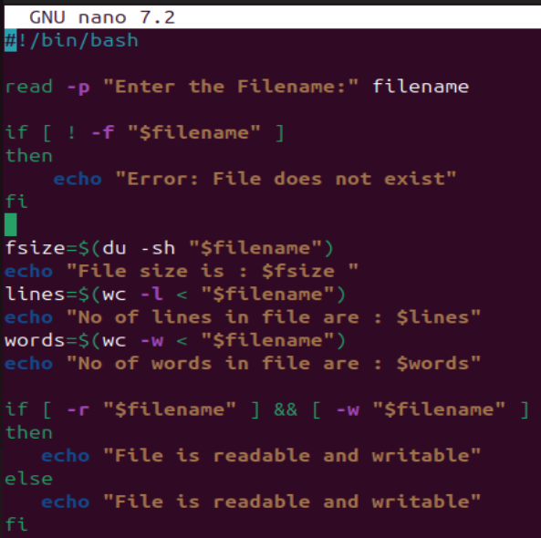
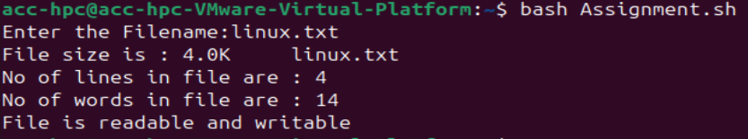

Q5. String Search
Write a shell script that:
- Accepts a sentence from the user.
- Accepts a word to search.
- Check whether the word exists in the sentence.
- Display "Found" or "Not Found".
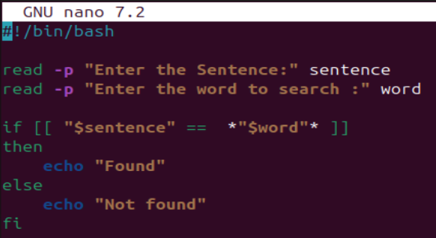
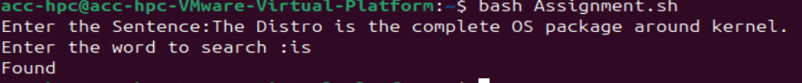

Q6. While Loop
Write a shell script using a while loop that:
- Displays numbers from 50 down to 1.
- Stop the loop if the number becomes 25.
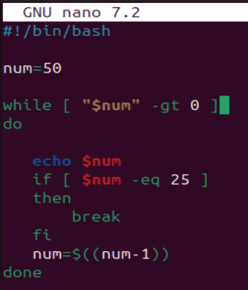
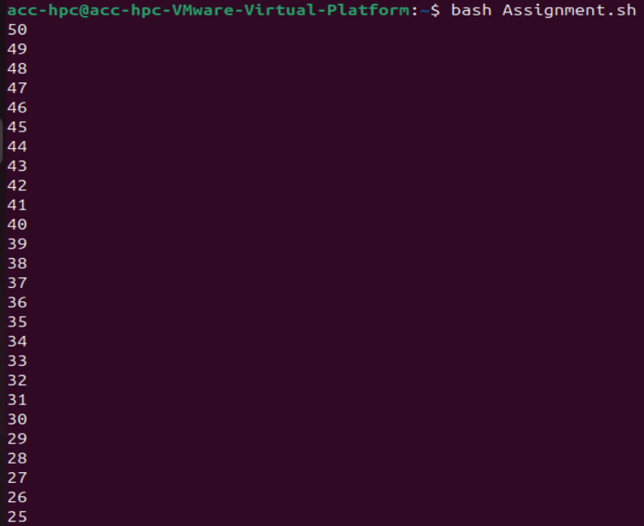

Q7. Until Loop
Write a shell script using an until loop that:
- Starts from 1.
- Prints numbers until it reaches 15.
- Display the square of each number.

Sample Output
1 -> 1
2 -> 4
3 -> 9
...
15 -> 225
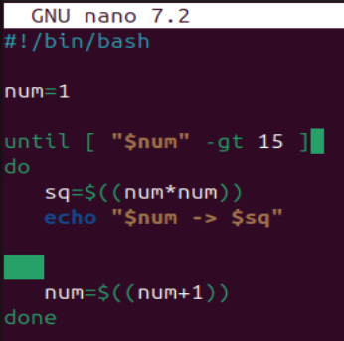
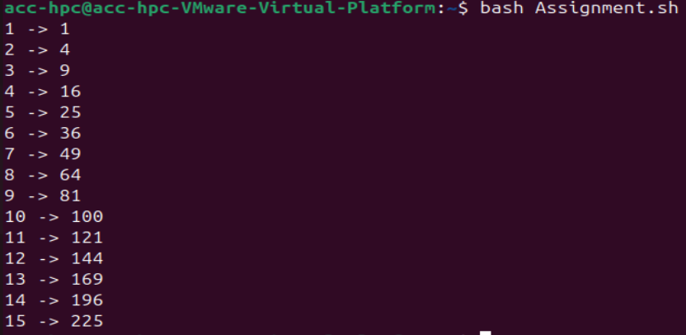

Q8. For Loop with Files
Write a shell script that:
- Uses a for loop to display the names of all .txt files in the current directory.
- For each file, also display its size in bytes.
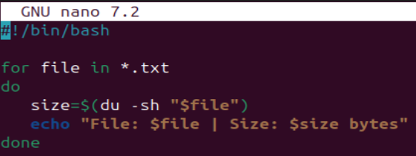
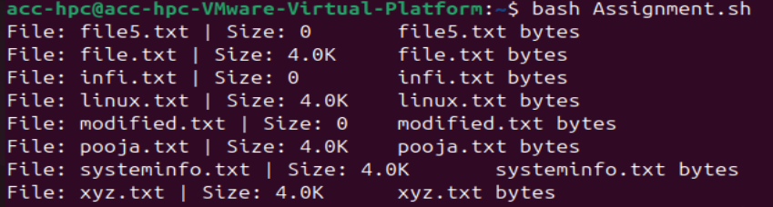

Q9. Variable, String and Loop
Write a shell script that:
- Accepts a word from the user.
- Using a loop, print each character of the word on a separate line.
- Finally display the total number of characters.

Example
Input: Linux

Output:
L
i n u x

Total Characters: 5
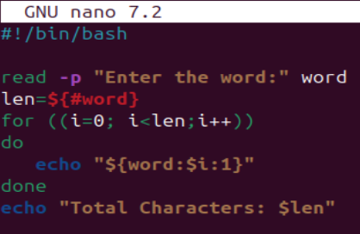
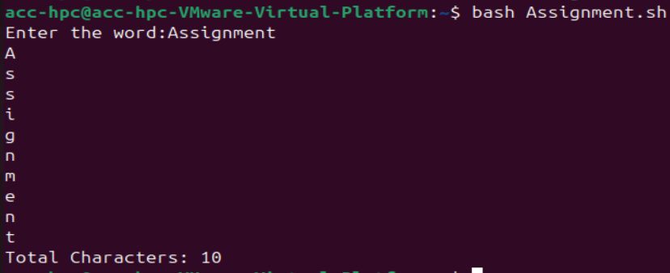

Q10. Until Loop with Directory Creation
Write a shell script that:
- Continuously asks the user to enter a directory name.
- If the directory already exists, ask again.
- Stop only when a new directory name is entered.
- Create the directory and display a success message.
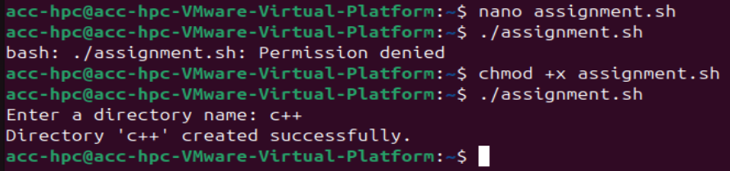
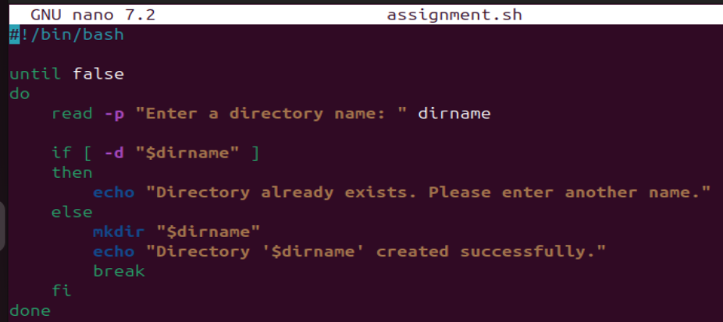

Assignment no: 7

Q1) semaphore initialized as a binary semaphore (1) multiple threads trying to enter a critical section checking/waiting for the lock sem_wait() → acquire/lock sem_post() → release/unlock only one thread enters the critical section at a time
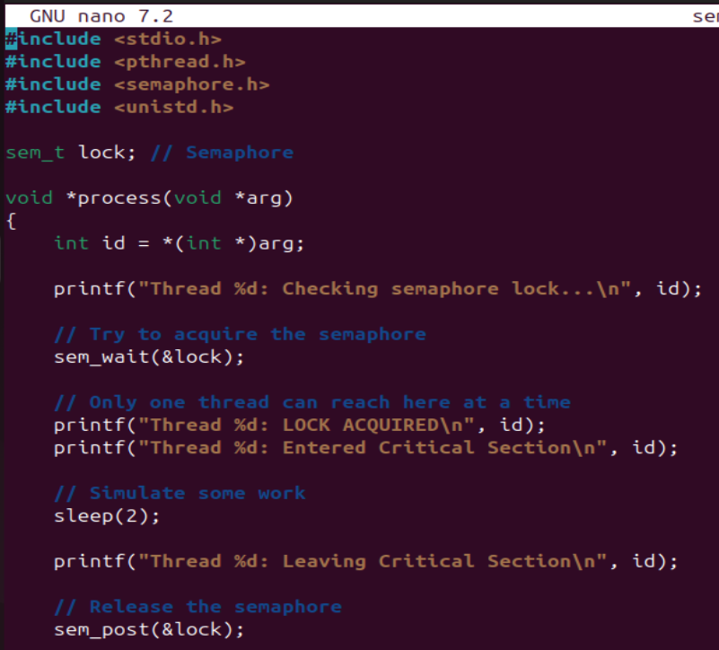
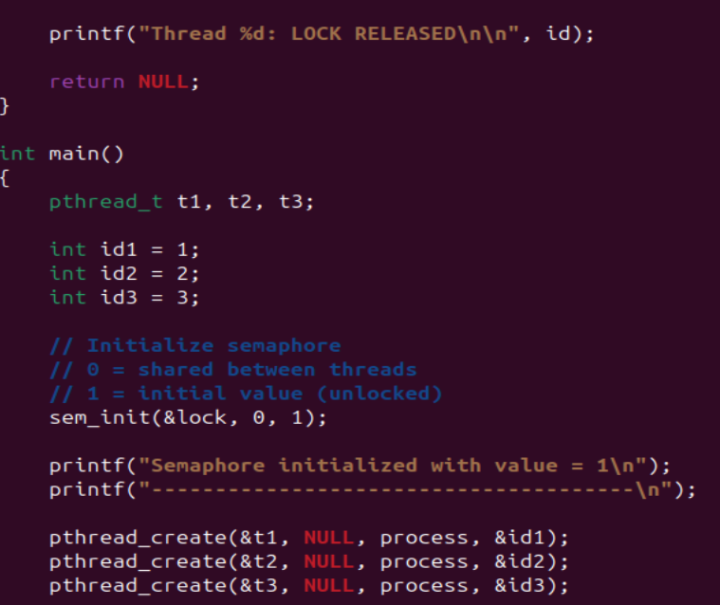
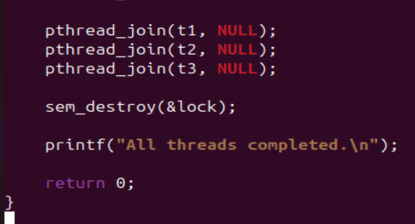
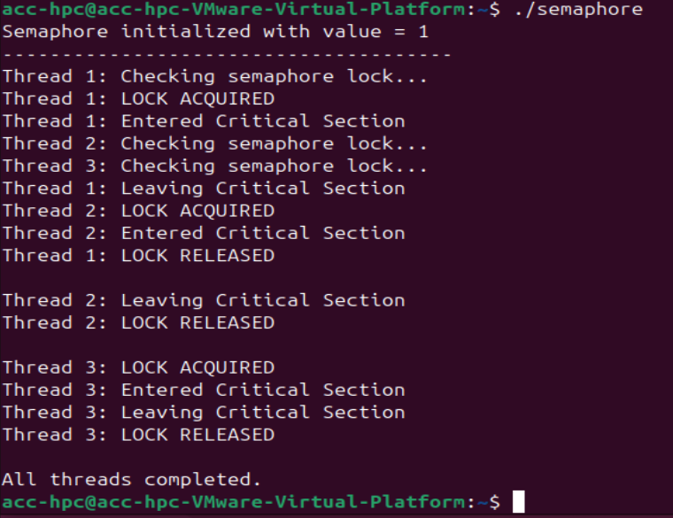
Q2) Symbolic permission command
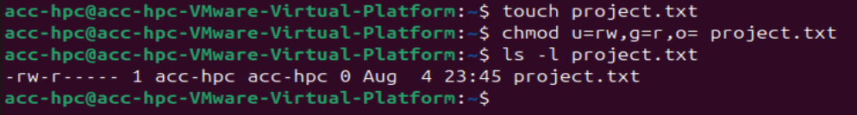
Q3) Numeric (Octal) Permission command
